# Compass MED D - Low Income Subsidy (LIS) Informational Overview

[Overview](#_Toc152845932)

[LIS Level - SCEs for Changes in Subsidy Level](#_Toc152845933)

[LIS Levels](#_Toc152845934)

[LIS Enrollees](#_Toc152845935)

[Checking LIS Status](#_Toc152845936)

[Self-Funded EGWP - Low Income Premium Subsidy Refund Checks](#_Toc152845937)

[LIS Redetermination Q&A](#_Toc152845938)

[Related Documents](#_Toc152845939)

**Description:** This document is to provide MED D Customer Care Representatives (CCRs) with a general overview of Low Income Subsidy (LIS), also known as Extra Help, in order to prepare them to address questions from MED D beneficiaries regarding this program.

|  |
| --- |
| Overview |

Medicare and the Social Security Administration provide Low Income Subsidy (LIS) to beneficiaries in order to assist with expenses involved with prescription drugs. Medicaid provides assistance with healthcare costs.

* This is also known as **Extra Help**,
* The **Extra Help** may pay for part or all of:
  + The monthly premium
  + Annual deductible
  + Part of the co-pay or coinsurance
* LIS is regulated by the government, and some beneficiaries must apply and subsequently qualify for LIS
* If beneficiaries fall under the following categories, they are deemed LIS and do not need to apply:
  + Recipients who receive Supplemental Security Income
  + Eligible for Medicare Savings Program
  + Eligible for full Medicaid benefits
* When a beneficiary is approved for LIS, the Social Security Administration assigns the beneficiary a LIS cost sharing level and notifies CMS
  + The LIS level determines the amount of **Extra Help** the beneficiary will receive
* CMS will notify the plan of the beneficiary’s LIS level
* SSA does cyclical redeterminations for some beneficiaries who currently receive LIS in order to determine if they will qualify for the following benefit year. Not everyone is reviewed every year

[Top of the Document](#_top)

|  |
| --- |
| LIS Level - SCEs for Changes in Subsidy Level |

The following **six** Subsidy Changing Events (SCEs) may result in a change in LIS eligibility or the beneficiary LIS level when they are reported.  The Social Security Administration will review eligibility for the program on an annual basis.

1.      Marriage

2.      Death of living-with spouse

3.      Divorce from living-with spouse

4.      Annulment from living-with spouse

5.      Separation from living-with spouse

6. Resumption of living together with previously separated spouse

Additionally, there are other factors that may result in the SSA recalculating a change in the Extra Help amount. SSA conducts the redetermination process annually.

Examples of **Other Events** include the following:

* **Beneficiary reports a change in household**
* **Beneficiary reports stop work and change in income**
* **Beneficiary reports change in resources**

[Top of the Document](#_top)

|  |
| --- |
| LIS Levels |

* There are three Low Income Subsidy levels or categories. The cost sharing for LIS levels are different each year.
* Below are the 2026 vs. 2025 Low-Income Subsidy premiums and cost-sharing.

 To review how LIS levels affect what a beneficiary pays on each of SilverScript plans, refer to the following documents:

* [MED D - 2026 SilverScript PDP Readiness Plan Design Reference](https://thesource.cvshealth.com/nuxeo/thesource/#!/view?docid=ec80b56d-0775-4025-9715-bab03365be57)

* [MED D - 2025 SilverScript PDP Readiness Plan Design Reference](https://thesource.cvshealth.com/nuxeo/thesource/" \l "!/view?docid=2b21522b-c27b-4b5a-a6c0-fc8805816fcc" \t "_blank)

|  |  |  |  |
| --- | --- | --- | --- |
|  |  | **2026** | **2025** |
| **LIS Category 1**    LIS eligible Beneficiaries with Incomes between 101% and 150% of Federal Poverty Level (FPL) | **Premium** | 100% premium assistance. However, if the beneficiary selects a plan with a premium above the benchmark premium for their state, the beneficiary will be responsible for the remainder. | 100% premium assistance. However, if the beneficiary selects a plan with a premium above the benchmark premium for their state, the beneficiary will be responsible for the remainder. |
| **Deductible** | $0 | $0 |
| **Generic/Preferred Drugs** | $5.10 | $4.90 |
| **Other** | $12.65 | $12.15 |
| **Above Out-of-Pocket Threshold** | $0 | $0 |
|  |  | **2026** | **2025** |
| **LIS Category 2**    LIS eligible Beneficiaries with Incomes up to 100% of the Federal Poverty Level (FPL) | **Premium** | 100% premium assistance. However, if the beneficiary selects a plan with a premium above the benchmark premium for their state, the beneficiary will be responsible for the remainder. | 100% premium assistance. However, if the beneficiary selects a plan with a premium above the benchmark premium for their state, the beneficiary will be responsible for the remainder. |
| **Deductible** | $0 | $0 |
| **Generic/Preferred Drugs** | $1.60 | $1.60 |
| **Other** | $4.90 | $4.80 |
| **Above Out-of-Pocket Threshold** | $0 | $0 |
|  |  | **2026** | **2025** |
| **LIS Category 3**    LIS eligible Beneficiaries are institutionalized or would be institutionalized if they were not receiving home and community-based services. (HCBS) | **Premium** | 100% premium assistance. However, if the beneficiary selects a plan with a premium above the benchmark premium for their state, the beneficiary will be responsible for the remainder. | 100% premium assistance. However, if the beneficiary selects a plan with a premium above the benchmark premium for their state, the beneficiary will be responsible for the remainder. |
| **Deductible** | $0 | $0 |
| **Generic/Preferred Drugs** | $0 | $0 |
| **Other** | $0 | $0 |
| **Above Out-of-Pocket Threshold** | $0 | $0 |

[Top of the Document](#_top)

|  |
| --- |
| LIS Enrollees |

**Full Benefit Dual-Eligible Enrollees (FBDE)** Low-income beneficiaries who are enrolled in both **Medicare** and **Medicaid** are known as Full Dual Eligible Enrollees.

* Full Dual-Eligible Enrollees are automatically enrolled into a Prescription Drug Plan (PDP) by CMS.
  + **NOT** all LIS participants are Full Dual-Eligible Enrollees
  + Full Dual-Eligible Enrollees qualify for payment of Medicare and Medicaid costs

**Auto Enrollment**

* CMS will enroll beneficiaries and Auto-Enroll each year if their current plan is going to have a premium above the benchmark. If not, the beneficiary stays in their current plan.

**Facilitated Enrollment**

* CMS facilitates enrollment of certain LIS beneficiaries into PDPs. This population is separate from the individuals auto assigned into a PDP.
* If an individual is facilitated into a PDP, their coverage will start two months after CMS receives notice of their eligibility.
* Facilitated Enrollment is the process by which other LIS beneficiaries who are eligible for the low-income subsidy are enrolled in a Part D plan.
* Other LIS eligible individuals are defined as:
  + Those deemed automatically eligible for LIS because they are eligible only for Medicaid payment of Medicare Part A and/or B premium and/or cost-sharing (Medicare Savings Program)
  + SSI-only (Medicare and Supplemental Security Income (SSI), but no Medicaid)

**OR**

* + Those who apply for LIS at the Social Security Administration or State Medicaid Agency and are determined eligible for LIS.

**Choosers**

Choosers are individuals who have Low Income Subsidy (Extra Help) and choose their own PDP. CMS does not reassign them into a PDP.

**Enhanced Wrap Benefit**

* LIS does **NOT** apply to Enhanced Wrap Benefit.
* LIS copays only apply to Medicare Part D plans (primary).
* If the medication is not covered through Medicare Part D, the beneficiary will be responsible for copay based on the supplemental plan.

**Health Plan or EGWP Enrollees**

If a beneficiary is part of a Health Plan or an EGWP beneficiary **AND** under LIS category 1, 2 or 3, they are **NOT** subject to the deductible.

[Top of the Document](#_top)

|  |
| --- |
| Checking LIS Status |

MED D CCRS can view LIS level for a beneficiary in the **Member Details** panel on the **Member Snapshot Landing Page** in Compass:

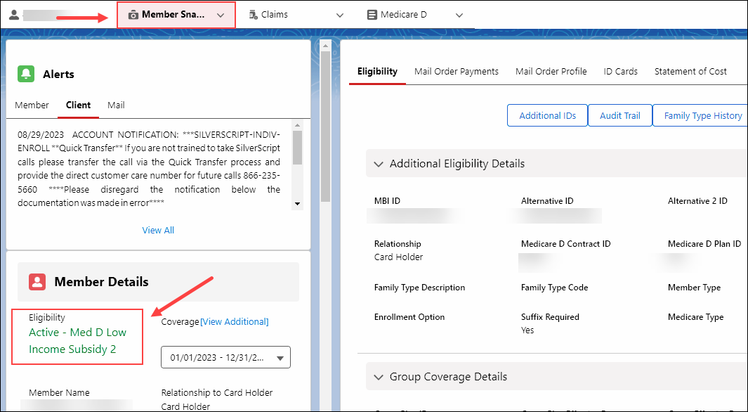

**Figure A**

** YOU ARE REQUIRED TO CHECK MARx** for the beneficiary’s LIS Status. IF YOU DO NOT HAVE ACCESS TO MARX, Warm transfer to the SENIOR TEAM. Refer to [MED D - Guide to Transferring a Call](file:///C:\Users\C337799\TSRC-PROD-029866).

Perform the following:

|  |  |  |  |
| --- | --- | --- | --- |
| **Step** | **Action** | | |
| **1** | **Log into MARx.**  Refer to **Logging into MARx** section of the[Med D – Accessing MARx](file:///C:\Users\C337799\TSRC-PROD-011902) work instruction. | | |
| **2** | Under the **Eligibility** menu, access the beneficiary’s profile.  Refer to **Viewing Medicare Eligibility Information in MARx** section of the[Compass MED D - Verifying Enrollment, Eligibility and LIS in MARx](https://thesource.cvshealth.com/nuxeo/thesource/" \l "!/view?docid=97073956-89ea-45dc-be12-d8b49af47bab) work instruction. | | |
| **3** | Scroll down to the **Low Income Subsidy Status** section.  Refer to the **Interpreting Medicare Eligibility Information in MARx** section of [theCompassMED D - Verifying Enrollment, Eligibility and LIS in MARx](https://thesource.cvshealth.com/nuxeo/thesource/#!/view?docid=97073956-89ea-45dc-be12-d8b49af47bab) work instruction. | | |
| **4** | Determine the beneficiary’s current Low Income Status level. | | |
| **If LIS Information...** | **Then…** | |
| Is displayed in MARx **AND**matches what is displayed in Compass | Our records currently match what is on file with SSA/CMS.  **CCR Process Note:** If the beneficiary has documentation showing a different LIS Level has been awarded, ask the beneficiary to fax the documentation to fax number **1-866-552-6205**. | |
| Is displayed in MARx **AND** **DOES NOT** match what is displayed in Compass | Determine who handles eligibility by reviewing the CIF eligibility section. | |
| **If eligibility is…** | **Then…** |
| Handled by Caremark | Transfer to the Senior Team to update account to match MARx.  Refer to [Compass MED D - When to Transfer Calls to the Senior Team](https://thesource.cvshealth.com/nuxeo/thesource/" \l "!/view?docid=0990aac5-274f-424d-9400-546d74b3fed7) and [Basic Call Handling](file:///C:\Users\C337799\TSRC-PROD-016401). |
| NOT handled by Caremark | CCR should follow the steps outlined in CIF for eligibility. |
| Is **NOT** displayed in MARx | Determine who handles eligibility by reviewing the **CIF eligibility** section. | |
| **If eligibility is …** | **Then…** |
| Handled by Caremark | I have reviewed your Low Income Status with SSA/CMS and no Low Income Status has been awarded to you. If you have documentation showing a different LIS Level has been awarded, fax the documentation to fax number **1-866-552-6205**.   * If no documentation is available, you or your legal representative will need to contact the SSA at **1-800-772-1213**.   + TTY users should call **1-800-325-0778**. |
| NOT handled Caremark | CCR should follow the steps outlined in CIF for eligibility. |

[Top of the Document](#_top)

|  |
| --- |
| Self-Funded EGWP - Low Income Premium Subsidy Refund Checks |

Around the 25th of each month, select Self-Funded - EGWP beneficiaries are sent a refund check based on the client’s direction. CCRs will not have any visibility to these refunds in Compass or FACETS. In the event, the beneficiary has questions regarding their refund check, transfer to the Senior Team. The Senior Resolution Team will reach out to the Account Manager for assistance. Refer [Compass MED D - When to Transfer Calls to the Senior Team](https://thesource.cvshealth.com/nuxeo/thesource/#!/view?docid=0990aac5-274f-424d-9400-546d74b3fed7) and [Basic Call Handling](file:///C:\Users\C337799\TSRC-PROD-016401).

**Note:**

* Check cannot be requested/reissued to the same address until 30 days after the original mailing date. (**Example:** April refund check mails on 04/25, a replacement can be requested on 05/25.)
* When CMS notifies the plan that an enrollee is deceased and eligibility shows an end date in Compass, the subsidy refund checks will no longer be issued.

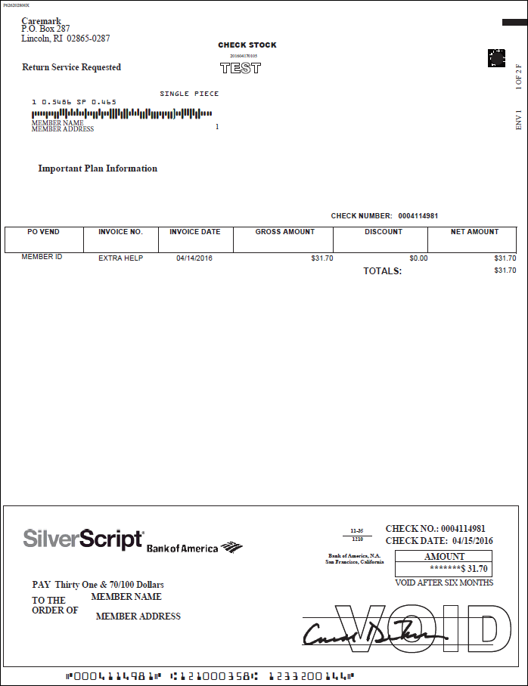

**Sample Check**

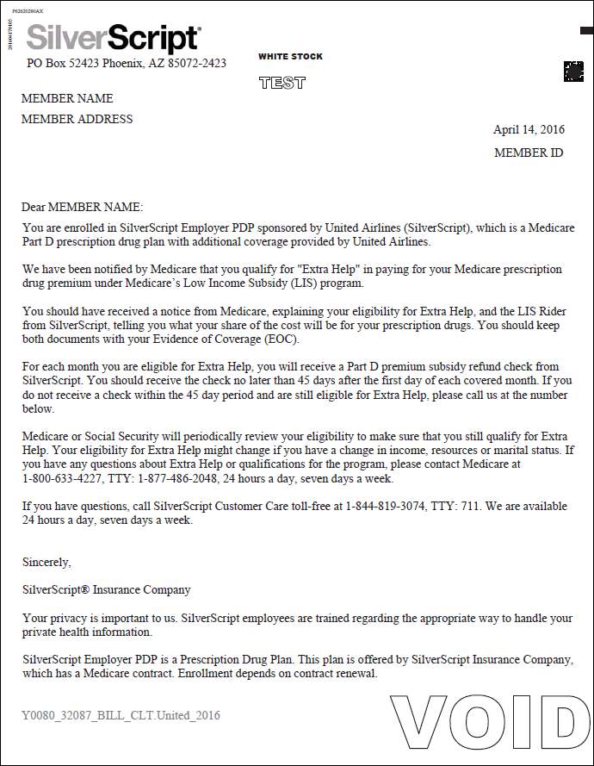

**Sample Letter**

[Top of the Document](#_top)

|  |
| --- |
| LIS Redetermination Q&A |

Use as needed:

|  |  |
| --- | --- |
| **Question** | **Answer** |
| **Does LIS apply to Enhanced Wrap Benefit?** | * No. LIS copays only apply to Medicare Part D plans (primary). * If the medication is not covered through Medicare Part D, the beneficiary will be responsible for copay based on the supplemental plan. |
| **Does a beneficiary’s LIS qualification change at any time?** | * A beneficiary’s qualification may change due to one of the six Subsidy Changing Events during the year. * As part of an annual process, CMS and the Social Security Administration determine if beneficiaries who qualified for Extra Help paying for Medicare prescription drug coverage in the current year will continue to qualify the following year. * There may be **Other Events**, such as change in income, change in resources and change in size of household that may impact a beneficiary’s Extra Help. These are subject for review and evaluated on a case-by-case basis. |
| **What factors affect beneficiaries who currently automatically qualify for Extra Help?** | * Some beneficiaries who automatically qualify for Extra Help in the current year will no longer automatically qualify in the following year. * Beneficiaries who no longer have both Medicare and Medicaid (full-benefit dual-eligibles), belong to Medicare Savings Programs (partial dual eligibles), or get Supplemental Security Income (SSI) benefits will no longer automatically qualify for Extra Help. * These beneficiaries will need to apply to Social Security or their State Medical Assistance (Medicaid) office to see if they still qualify for Extra Help based on their income and resources. * Other beneficiaries will continue to automatically qualify for Extra Help in the current year, but their co-payment levels will change.   + The change in co-payment level could result from a change in their Medicaid eligibility.   **Example:**  They may have had a change from one of the following categories to another:   * Having Medicare and Medicaid and residing in an institution * Having Medicare and Medicaid * Belonging to a Medicare Savings Program * Receiving SSI benefits but not Medicaid |
| **How will a beneficiary know if they no longer automatically qualify for Extra Help?** | * Beneficiaries who will no longer automatically qualify for Extra Help will receive a grey letter from Medicare in late September. * The letter includes a paper application for Extra Help from Social Security and a pre-addressed postage-paid envelope. * These individuals can apply to see if they still qualify for Extra Help based on their income and resources. |
| **What should a beneficiary do if they no longer automatically qualify for Extra Help in the following year?** | * Beneficiaries who no longer automatically qualify for Extra Help should apply to Social Security or their State Medical Assistance (Medicaid) office as soon as possible to see if they still qualify for Extra Help based on their income and resources. * If a beneficiary’s situation changes so that they again automatically qualify, Medicare will send another purple notice, letting the individual know that they qualify. * Beneficiaries who no longer qualify for Extra Help should look at other options that may help pay their drug costs, including available State and local programs. * They may also want to compare available Medicare drug plans to their current Medicare drug plan to see if they can save money. * When comparing plans, beneficiaries should check to make sure the plan covers the prescriptions they take and includes the pharmacies they use. * Beneficiaries can call their State Health Insurance Assistance Program (SHIP) for free personalized counseling about their choices. * Refer to [Compass MED D - SHIP Counselor Calls For CVS Caremark Part D Plans](file:///C:\Users\C337799\Downloads\TSRC-PROD-061877). |
| **How will beneficiaries know if their co-payment amounts will change?** | * Beneficiaries whose co-payment amounts will change as of January 1 of the following year will receive an orange letter from Medicare in early October letting them know their new co-payment amounts. * Co-payment amounts may either increase or decrease due to a change in Medicaid eligibility. |
| **What should a beneficiary do if they think there’s been a mistake determining their eligibility for Extra Help?** | * For any questions, beneficiaries could call 1-800-MEDICARE (1-800-633-4227). * TTY users should call 1-877-486-2048. * Callers who report that they are still Medicaid eligible will be directed to their State Medicaid Agencies. |
| **What is the process SSA uses for beneficiaries who do not automatically qualify for Extra Help but applied and qualified for Extra Help?** | * The Social Security Administration reviewed the eligibility of beneficiaries who applied and qualified for Extra Help. * Social Security mailed these beneficiaries a letter telling them what Social Security’s records show a change in their income (not including cost of living increases), resources, and household size * Beneficiaries who don’t have changes to their income, resources, or household size will have to indicate on the form that no changes occurred and return the form within 30 days. * Beneficiaries who have any changes to their income, resources, or household size will need to return a one-page letter to Social Security within 30 days to explain the changes. * Social Security will then mail a form for them to fill out and return called Social Security Administration Review of Your Eligibility for Extra Help (Form 1026-SM-REDE). * Social Security will also send the eligibility review form (Form 1026-SM-REDE) directly to some beneficiaries to complete because Social Security has information that there was a change in income or resources. * This form needs to be returned within 30 days. * Social Security will review the eligibility review form (Form 1026-SM-REDE) and send the beneficiary a letter explaining its decision.   **Social Security may decide a beneficiary:**   * Has no change in the amount of Extra Help they receive, or * Has an increase in the amount of Extra Help they receive, or * Has a decrease in the amount of Extra Help they receive, or * No longer qualifies for Extra Help |
| **What if a beneficiary doesn’t agree with Social Security’s decision?** | * Beneficiaries have the right to appeal if they disagree with Social Security’s decision. * The decision letter they get from Social Security will explain their appeal rights. |
| **Will everyone with Extra Help get a letter from Medicare or Social Security?** | * Beneficiaries who continue to automatically qualify for Extra Help in the following plan year will receive a letter from Social Security. |
| **Where can beneficiaries get more information about applying for Extra Help?** | * Beneficiaries who have questions about filling out the application for Extra Help should visit www.socialsecurity.gov on the web or call Social Security at 1-800-772-1213. * TTY users should call 1-800-325-0778. |
| **Are Medicare letters available in non-English languages upon request?** | * To request a translation of the notice, beneficiaries can call 1-800-MEDICARE (1-800-633-4227). * TTY users should call 1-877-486-2048. |

[Top of the Document](#_top)

|  |
| --- |
| Related Documents |

**Parent SOP:** CALL-0048: [Medicare Part D Customer Care Call Center Requirements-CVS Caremark Part D Services, L.L.C.](https://policy.corp.cvscaremark.com/pnp/faces/SecureDocRenderer?documentId=CALL-0048&uid=pnpdev1)

**Abbreviations/Definitions:** [Abbreviations / Definitions](file:///C:/Users/u041913/AppData/Local/Microsoft/Windows/INetCache/Content.Outlook/AppData/Local/Microsoft/Windows/INetCache/Content.Outlook/AppData/Local/Microsoft/Windows/INetCache/Content.Outlook/AppData/Local/Microsoft/Windows/INetCache/Content.Outlook/40ZZSJWS/CMS-2-017428)

[Top of the Document](#_top)

Not to Be Reproduced or Disclosed to Others without Prior Written Approval

**ELECTRONIC DATA = OFFICIAL VERSION - PAPER COPY = INFORMATIONAL ONLY**